Date: / / 2018

Dear Researcher,

Subject: Proofreading

Kindly, after completing the modifications requested by the reviewers, submit the research paper for proofreading to an Arabic/ English editor, sign the below notice and attach it with the research paper after it has been modified.

Prof. Husni Awad
Dean of Scientific Research

Notice

I, the undersigned, Maher Nazmi Qarawani, herby inform the Editorial Board of the Palestinian Journal of Technology and Applied Sciences that I have submitted the research paper presented for publication, under the title of
Hyers-Ulam-Rassias Stability of The Inhomogeneous Wave Equation
, for proofreading. I declare it is free of any typographical errors or grammatical mistakes and I shall take full responsibility for any errors that have not been edited.

Signature:
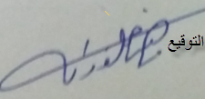

Date: 3 /11 /2018

