HAYMAN DIALLEL ANALYSIS OF SOME MELON (Cucumis melo L.) INBRED LINES FOR FRUIT QUALITY TRAITS

تقييم صفات الثمار النوعية لبعض سلالات البطيخ الأصفر المرباة داخليا باستخدام طريقة هايمان للتهجين الدائري الكامل

د. هشام فوزات العطواني: باحث في الهيئة العامة للبحوث العلمية الزراعية- مركز بحوث السويداء.

- Hesham Fuzat Alatwani: Sweida Research Center -General Commission for Scientific Agricultural Research (GCSAR), Damascus, Syria.hatwani30@gmail.com.
*Corresponding Author: hatwani30@gmail.com.

د. فاتن ممدوح الصفدي: باحث مساعد في الهيئة العامة للبحوث العلمية الزراعية- مركز بحوث السويداء.
-Faten Mamdouh alsafadi: Sweida Research Center -General Commission for Scientific Agricultural Research (GCSAR), Damascus, Syria.f.alsafadi@gmail.com.

د. عبد المحسن خليل مرعي: باحث في الهيئة العامة للبحوث العلمية الزراعية
- Abdel Mohsen Khalel Marie: General Commission for Scientific Agricultural Research, Damascus, Syria.abdmmurie@yahoo.com.

د. رمزي فهد مرشد: أستاذ مساعد في قسم علوم البستنة– كلية الزراعة - جامعة دمشق.
- Ramzi Fahed Murshid: Department of Horticulture Science, Faculty of Agriculture, University of Damascus, Damascus, Syria.rammur76@yahoo.fr.

HAYMAN DIALLEL ANALYSIS OF MELON (Cucumis melo L.) INBRED LINES FOR FRUIT QUALITY TRAITS

ABSTRACT:

The present study was conducted at Swaida agricultural research center, Syria, during the season 2019, to estimate the genetic components of six melon (Cucumis melo L.) inbred line and their 30 F_{1s} hybrid produced by complete diallel mating design, to evaluate some fruit quality traits( dry mater, total soluble content TSS, total sugar, Carotene and vitamin C) using Hyman analysis approach.The results showed that all the studied traits was controlled by over dominant gene effect, and most of parents carried more dominant genes than recessive, since the H1 was greater than D for all studied traits. The low values of narrow sense heritability indicating the importance of non-additive gene effect for the studied traits. According to the values of Wr+Vr showed that P5(IL-CM116) carried the most dominant genes for most of studied traits, while P2(IL-CM106) have the most recessive genes for all studied traits

Key wards: Cucumis melo, Melon, diallel, Hayman, narrow sense heritability.

تقييم صفات الثمار النوعية لبعض سلالات البطيخ الأصفر المرباة داخليا باستخدام طريقة هايمان للتهجين الدائري الكامل

الملخص:

أجريت هذه الدراسة في مركز البحوث العلمية الزراعية بالسويداء - سوريا، خلال الموسم 2019 ، لتقدير المكونات الوراثية لست سلالات من البطيخ الأصفر(Cucumis melo L.) و 30 هجيناً ناتجة عن التهجين التبادلي الكامل ، لتقييم بعض صفات الثمار النوعية (المادة الجافة، المواد الصلبة الكلية الذائبةTSS ، السكريات الكلية، محتوى الثمار من الكاروتين وفيتامين (C باستخدام تحليل هايمان .Hyman أظهرت النتائج أن جميع الصفات المدروسة تخضع لتأثير السيادة الفائقة للجينات ، وأن معظم الآباء يحملون جينات سائدة أكثر من المتنحية، لأن H1 كانت أكبر من D لجميع الصفات المدروسة. تشير القيم المنخفضة لدرجة التوريث بالمعنى الضيق إلى أهمية التأثير الجيني غير المضيف في وراثة الصفات المدروسة. أظهرت قيم( Wr + Vr) أن P5 (IL-CM116) يحمل أكبر عدد من الجينات السائدة لمعظم الصفات المدروسة، بينما يمتلك P2(IL-CM106)أكثر الجينات المتنحية لجميع الصفات المدروسة.

الكلمات المفتاحية: البطيخ الأصفر، التهجين التبادلي، تحليل هايمان، درجة التوريث الضيقة.

HAYMAN DIALLEL ANALYSIS OF SOME MELON (Cucumis melo L.) INBRED LINES FOR FRUIT QUALITY TRAITS

INTRODUCTION
Melon (Cucumis melo L., 2n=2x=24) is one of the most economically important species of the cucurbitaceae family (Burger et al., 2003; Saha et al., 2018), the origin of melon was firstly considered from Africa, but recent studies indicated that cucumber and muskmelon both are from Asian origin with wide diversity of Cucumis melo wild species which exist in China and India (Sebastian et al 2010). Melon fruit is one of the most summer fruits because of its high nutritive and medicinal value, musky flavor, sweetness and aroma. (Abo Sedera et al., 2016).
The great diversity of melon around the world and the several botanical type of fruits, chemical content play an important role in the marketing. good fruit genotype market-standard size, good flesh thickness, small internal cavity, high flesh firmness and high soluble solids content (Nunes et al., 2005), in addition for high total sugar content, carotene and the level of vitamin C. (Abo Sedera et al., 2016). The improvement program for fruit quality trait of melon have to focus on more than one melon type, since breeding program of melon based mainly on exploiting natural sources of germplasm by means of selection and hybridization followed by selection(Mliki et al.,2001).
Selection and hybridization are two basic methods for crop improvement. The success of selection mainly depends upon the extent of broad genetic base (Singh, 1998). The utilization divergent genotypes in diallel hybridization design can create higher genetic base. In addition for that, information about gene interaction that covered the main agronomic traits of a species is fundamental to genetic improvement can be acquired through diallel crosses. It uses information about the performance of parents and their hybrids (Pandeyet al.,2010).
The numerical approach of diallel analysis provides a good information about additive and dominance gene effect and the allied statistics. The genetics largely depends upon the relative magnitude of these two components in the prediction the gene interaction that control the desirable traits (Walton, 1968).
The aim of this study was to estimate the genetic parameters that control some fruit quality traits of melon in a set of 6 melon inbred lines as parents and their 30 F₁diallel crosses.

MATERIAL AND METHODS:
The present study was conducted in the experimental field at Swaida research center, Syria. During the summer season of 2019 to study the genetic behavior of some quality traits for six melon inbred lines.

Plant material
Six melon inbred lines were obtained from the vegetable department of the general commission for scientific agricultural researches (GCSAR), Syria. The source of these lines was some of local melon populations. The six inbred line (Table 1) were crossed in diallel mating design to obtain 30 F₁ hybrids. During season 2019 the 36 muskmelon genotypes (6 parents and 30 F₁) were evaluated for some fruit chemical quality traits.

Table 1: The six melon inbred lines and their parental number
Genotype name | Parental Number
IL-CM104 | P1
IL-CM106 | P2
IL-CM108 | P3
IL-CM113 | P4
IL-CM116 | P5
IL-CM118 | P6
Experimental design
The 36 melon (6 parents and 30F₁) genotypes were evaluated in Randomized complete blocks design (RCBD) with four replications, each experimental plot was one row of 8 meter in length and 1.5 m between lines. The distance between plants in each row was 80 cm.
All the cultural practices were done as recommended for melon and the control of diseases and insects was practiced according to the recommendation of ministry of agriculture.

Measurements
- Dry mater
The dry mater was determined according to Kirk and Sawyer (1989), by placing 100g of juice in
the oven at 80° until weight stabilizes.
- Total soluble solid (TSS)
It was measured using refractometer (Matest- 24048 -Italy).
- Total sugar
Total sugars content in the fruit of experimental plot expressed by titration of Fehling’s A
and B stock solution and Methylene Blue as indicator, until the blue color disappears,
(Takahashi, 1959).
- Carotene
Total carotenoids content in the fruit of experimental plot was determined using the
spectrophotometer (UK-106) according to the method described by Beerh and Siddappa
(1959) at wavelengths 470, 645 and 662.
- Vitamin c
The vitamin C contents were determined according to the method described by Ismail et al.,
(2014), by titration using Iodine solution and starch as indicator.

Statistical analysis:
Diallel analysis for inbred line parents and their F1 was carried out according to Hayman’s (1954) approach. Hayman partitioned the total sum of the square due to genotypes into four components ; the additive component with (P-1) degree of freedom, non-additive effect with p(p-1)/2 degree of freedom , maternal and reciprocal effects with (p-1) and p(p-1)/3 degree of freedom, respectively. Were p is the number of parents involved in crosses. The non-additive component is further partitioned into b1 with 1 degree of freedom, which shows the direction of dominance, b2 with p-1 degree of freedom indicating gene asymmetry, If b2 is significant, it indicates that some parents possess more dominant genes than others. Another component, the b3 with p(p-3)/2 degree of freedom measures residual dominance effect and also dominance effects specific to individual crosses.
Hayman method involve the computation of the following statistics:
- Variance of the parental mean (V0L0)
- Variance of the component of each array(Vr)
- Covariance of the parents with their offspring in each array(Wr)
- The mean performance of parents Yr

The genetic component estimated under this analysis were:
- D : is defined as the component of variation due to additive effects of genes.
- H1: is the component of variation due to dominance effects of genes.
- H2: Proportion of dominance due to positive and negative effect of genes.
- F: the mean of 'Fr' over the arrays (F), Fr is the covariance of additives and non-additive effects in single array.
- h2: The dominance effects (as the algebraic sum over all loci in heterozygous phase in all crosses).

The genetic components of variation was used to estimates the following statistics:

- (H1/D)^{1/2}: The mean degree of dominance over all loci, If (H1/D)^{1/2} in the range
between 0-1 indicating partial dominance effect, greater than 1
donates over dominance effect.
- H2/4H1: The proportion of genes with positive and negative effects in the
parents. The value should have the maximum of 0.25 when the
positive and negative alleles in symmetrical distribution.
Asymmetrical distribution in a value less than 0.25.
- (Kd/Kr)=((4DH1)^{1/2} + F) / ((4DH1)^{1/2} – F) : The proportion of dominant to
recessive genes
- (h2/H2): Number of groups of genes that control the trait.
- Coefficient of correlation (r) between Wr + Vr and Yr: if the correlation is
negative tends to increase the trait.
- (1/4 D/(1/4(D+H1-F)+E))*100 : Narrow sense heritability

The Wr/Vr graph are the other powerful tools in Hayman’s analysis. Parents which possess smaller values of (Wr+Vr) have more of the dominants genes and lie near to the point of origin, and those with higher values of (Wr+Vr) possess the most recessive genes and lie furthest from the point of origin. The intercept of Wr/Vr regression line indicates the degree of dominance. If the regression line intercepts the Wr axis above the point of origin, this indicates partial dominance. If the regression line passes through the origin, then there is complete dominance. If the regression line passes below the point of origin, then over dominance contributes to the expression of the trait.
Hayman diallel analysis was carried out using AGD_R software, a free software developed by International Maize and Wheat Improvement Center (CIMMYT)
RESULTS
The analysis of variance according to Hayman diallel approach showed highly significant differences among the 36 genotypes (6 parents and 30 F1 crosses) for all studied fruit quality traits (Table2). This results indicated that the genetic parameter estimates can be performed on all the observed characters. Significant mean squares were observed for additive and non-additive components for all studied characters indicating the importance of both gene actions in the inheritance of these traits. The non-additive components were further partitioned into b1 with 1 degree of freedom, b1 were highly significant in total sugar and Carotene traits implying presence of directional dominance, b2 with p-1 degree of freedom, were highly significant in all studied trait except vitamin C indicating gene asymmetry among parents in other words some parents have more dominant genes then others, b3 with p*(p-2)/2 degree of freedom, b3 were highly significant for all studied traits showing that dominance effect is specific to some individual crosses.
Table 2: Mean square for Hyman diallel analysis for fruit quality traits
Vitamine C | Caroten | Total Sugar | TSS | Dry mater | df | Source of variance
489.748 | 56.67 | 0.520 | 0.970 | 0.28 | 3 | Replication
847.645** | 184.734** | 2.305** | 1.984** | 4.79** | 35 | Genotype
1081.272* | 776.388** | 2.598** | 4.080** | 4.59* | 5 | Additive
867.023** | 127.703** | 3.507** | 2.283** | 5.16** | 15 | Non-Additive
629.068 | 461.781** | 20.053** | 1.176 | 0.003 | 1 | b₁
455.019 | 139.458** | 2.601** | 3.985** | 6.72*** | 5 | b₂
1122.353** | 84.053* | 2.172** | 1.460** | 4.87** | 9 | b₃
308.442 | 61.549 | 1.150 | 0.525 | 6.65** | 5 | Maternal
971.367** | 36.047 | 0.934 | 1.218* | 3.40* | 10 | Reciprocal
377.200 | 33.092 | 0.781 | 0.545 | 1.46 | 105 | Error
*and ** , significant and highly significant at 5 and 1% respectively.
Gene interaction:
The regression coefficient test b(Wr,Vr) was not significant for all studied traits(Table 3), that is means no interaction among genes that controlling these traits, these results indicating that one of Hayman diallel assumption can be met.
Estimation of genetic components:
- The effect of additive and dominant gene action:
The estimation of additive genetic components (D) and dominance components (H1) and (H2) showed highly significant differences for dry mater, TSS and carotene indicating the importance of additive and non-additive effect in the inheritance of these traits. On the other hand, only the dominance components (H1) and (H2) were highly significant for total sugar and vitamin C suggesting that the non-additive effect plays an important role in the inheritance of these two traits.
- The mean degree of dominance:
The degree of dominance ((H1/D) ^{1/2}) were 1.51, 2.03, 3.8, 1.32 and 2.5, since these values were >1, the over dominance effect direct the inheritance towards plant that contains high level of dry mater, TSS, total sugar, carotene and vitamin C, respectively.
- The proportion of genes with positive and negative effects:
The proportion of genes with positive and negative effects (H₂/4H₁) was less than 0.25
(Table 3),indicating gene asymmetry and unequal distribution for alleles that increased and decreased all studied traits except vitamin C. These results were in the same trend with significant and non-significant values of b2 which indicates asymmetrical and symmetrical gene distribution, respectively.
- The proportion of dominant to recessive genes:
The proportion of Dominant to Recessive Genes (KD/KR) was >1 for all studied traits
(Table 3), showing that the six parents used in this study carrying more dominant than recessive genes for all traits, this supported by the positive values of F which indicates that there were more dominant than recessive allels in the parents used in this study. On the other hand, the correlation coefficient r between parental mean Yr and the value of (Vr+Wr) was negative for all studied traits except dry mater. The negative values of r indicating that dominance tends to increase trait. On the other hand, positive value of r for dray mater trait indicates that dominance tends to decrease the dry mater contents.

Table 3: Estimation of genetic parameter for melon fruit quality traits using the diallel analysis
of Hayman method
Vitamin C | Caroten | Total Sugar | TSS | Dry mater | Genetic parameters
0.37_{NS} | 0.866_{NS} | 0.307_{NS} | 0.47_{NS} | 0.93_{NS} | Covariance-variance regression (b(Wr, Vr))
144.16_{NS} | 71.19** | 0.119_{NS} | 0.449** | 1.76** | Additive effect (D)
902.1** | 124.41** | 1.72** | 1.85** | 3.99_{NS} | Dominance effect (H₁)
903.22** | 112.36** | 1.69** | 1.76** | 3.44** | Proportion of dominance due to positive and negative effect of genes (H₂)
195.95_{NS} | 59.44** | 0.311_{NS} | 0.88_{NS} | 1.99_{NS} | F_{r} mean (F)
34.54_{NS} | 60.05** | 2.68** | 0.08_{NS} | -0.19_{NS} | F₁ deviation from the average parent (h₂)
95.08** | 8.43** | 1.93_{NS} | 0.14_{NS} | 0.365_{NS} | Environment (E)
2.50 | 1.32 | 3.80 | 2.03 | 1.51 | Mean degree of dominance ((H1/D)^{1/2})
0.25 | 0.225 | 0.245 | 0.23 | 0.215 | Proportion of positive genes to negative genes (H₂/4H₁)
1.74 | 1.93 | 2.044 | 2.87 | 2.21 | The proportion of dominant to recessive genes (K_{d}/K_{r})
0.038 | 0.53 | 1.58 | 0.04 | -0.05 | Number of groups of genes (h₂/H₂)
-0.69 | -0.77 | -0.87 | -0.82 | 0.69 | Coefficient of correlation (r) between Wr + Vr and Yr
11.70 | 41.90 | 1.55 | 14.42 | 33.71 | Narrow-sense heritability (h2_{NS})
NS: not significant , *and ** , significant and highly significant at 5 and 1% respectively.

- Number of groups of genes controlling the studied traits.
The numbers of gene groups that controlling the fruit quality traits was estimated from (h2/H2) values. These values were less than 1 for all studied traits except total sugar. Indicating that these traits is controlled by one group of genes, while total sugar trait (h2/H2=1.58) is controlled by two main groups of genes (Table3).
- Direction and order of dominance
The order of dominance of the 6 parents to dry mater was IL-CM104, IL-CM118, IL-CM113, IL-CM116, IL-CM108 and IL-CM106 (Table 4). The parent IL-CM106 possess the most recessive gene because it is the most distance from the point of origin. In the meantime, IL-CM104 contained the most dominant genes since it’s the closest to the point of origin. The regression line of Wr-Vr graph intercept the Wr axis under the origin (0), indicating the over dominance effect on the inheritance of dry mater (Figure1).
The order of dominance of parents for total soluble contents (TSS) was IL-CM113,IL-CM116,IL-CM104,IL-CM108, IL-CM118 and IL-CM106 (Table). IL-CM106 carried the most recessive genes while IL-CM113 carried the most dominant genes. The regression line on the graph of Wr -Vr has a value of intercept a = -0.11, so cut the Wr axis under the origin (0). Cutting point at that position indicates over dominant gene action (Figure 2).
Regarding to the total sugar trait, the parent 5 (IL-CM116) carried the most dominant genes, since it was the closest to the origin point, while parent 2(IL-CM106) have the most recessive genes. The regression line of Wr-Vr intercepted Wr axis under the origin, indicating over dominance gene action covering the inheritance of total sugar (Figure3).
The order of dominance of parents for Carotene was IL-CM116, IL-CM113,IL-CM108, IL-CM118, IL-CM104 and IL-CM106. The parents IL-CM116 and IL-CM106 carried the most dominant and recessive genes, since they were the closest and furthest to the point of origin, respectively. The Wr- Vr regression line cut the Wr axis over the point of origin indication partial dominant gene effect (Figure4).
According to the Wr+Vr values for Vitamin C content, the order of dominant parent was IL-CM116, IL-CM108, IL-CM118, IL-CM113, IL-CM104 and IL-Cm106. Parent 5 (IL-CM116) possess the most dominant genes, and parent 2(IL-Cm106) have the most recessive gene of this trait. The partial dominant effect controlling the inheritance of Vitamin C fruit contents, since the Wr-Vr regression line cutting the Wr axis over the point of origin (figure 5).

Table 4: Wr+Vr values of the six parents for melon fruit quality traits.
Genotype | Dry mater | TSS | Total Sugar | Carotene | Vitamin C
IL-CM104(p1) | -0.01 | 0.32 | 0.53 | 85.18 | 298.28
IL-CM106(P2) | 3.57 | 1.22 | 1.81 | 129.08 | 427.53
IL-CM108(p3) | 1.82 | 0.38 | 0.23 | 56.37 | 37.01
IL-CM113(p4) | 0.31 | 0.13 | 0.22 | 36.65 | 208.86
IL-CM116(p5) | 0.62 | 0.15 | 0.07 | 7.73 | 35.74
IL-CM118(p6) | 0.20 | 0.41 | 0.23 | 59.37 | 158.28

- Heritability:
The narrow sense heritability was less than 50% for all studied traits(Table 3), indicating the predominant of non- additive gene action for all studied traits. These results were supported by the positive values of "F' suggested that the heterosis breeding might be the good manner to get higher quality trait of melon.

DISCUSSION
Diallel analysis is most balanced and systemic experimental design to examine continuous variation. The genetic knowledge about the parental population becomes available in the early generation, and this is plays an important role in defining breeding strategy without losing much time (Debnath, 1988). The estimation of genetic parameter using diallel crosses analysis can be carried out if there are a significant difference among genotypes using analysis of variance of the observed variable (Singh & Chaudhary 1979). In the present study, the fruit quality traits showed highly significant differences among the studied genotypes (6 parents and 30F_{1s}), thus, the further analysis of Hyman approach can be done. These results were in agreement with Mohammadai et al., (2014) andAbo Sedera et al., (2016).
The genetic interaction among the genes that controlled the studied traits can be seen from the value of the regression coefficient b (Wr,Vr). If the value is not significantly different from one, indicating no interaction among the genes (Sousa and Maluf 2003). In the study, the b values were not significant for all studied traits. Regarding to these results, one of the Hayman diallel assumption can be met.
The mean degree of dominance (H1/D)^{½} which was over than 1 for all studied traits, confirmed the over dominance gene action, these results was supported by the dominant component of variance (H1) which was higher than the additive component (D) for all studied traits. In addition, for that, the predominance of over dominant gene action and the low values of the narrow sense heritability suggested that selection in the segregation generation to improve fruit quality traits depends mainly on heterotic individual plants. These results were in accordance with (Abou kamer et al., 2015; Glala et al., 2012; Iban et al., 2007; Mohammadi et al., 2014; Reddy et al., 2013 and Shamloul and Askar, 2011).
The proportion of dominant to recessive genes in the 6 inbred line parents was estimated by the value of Kd/Kr, this value was > 1 for all studied traits, indicating that there was more dominant than recessive genes in the parents used in this study. On the other hand, the proportion h2/ H1 was less than 0.25 for all studied traits except Vitamin C, the values of h2/H1 less than 0.25 showed unequal distribution of dominant genes among parents. In the same trend, the number of dominant genes among parents is determined by the value of Wr+Vr. Parent which showed the lowest value of Wr+Vr carried the most dominant genes that controlling the studied trait. According for that, parent 2 (IL-CM106) carried the most recessive genes for all studied traits. On the other hand, parent 5(IL-CM116) was the most dominant parent for all studied traits except TSS. While parent 4 (IL-CM113) carried the most dominant genes for TSS trait. These results were in the same trend with Bayoumy et al. (2014) and Abo Sedera et al.(2016).
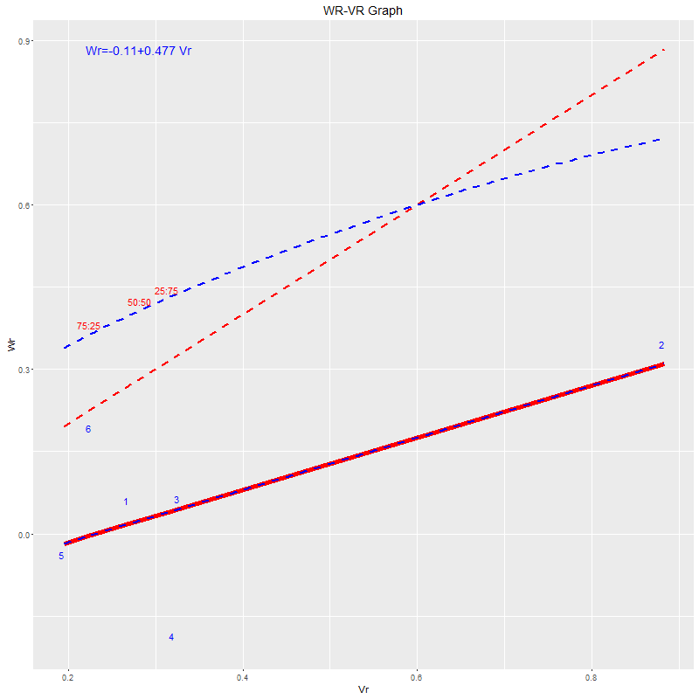

Figure 1: The graph of variance (Vr) and covariance (Wr) for dry mater of fruit in the F₁ generation of
melon genotypes.[1:parent IL-CM104, 2: parent IL-CM106, 3: parent IL-CM108, 4:parent
IL-CM113, 5: parent IL-CM116, 6: parent IL-CM118].
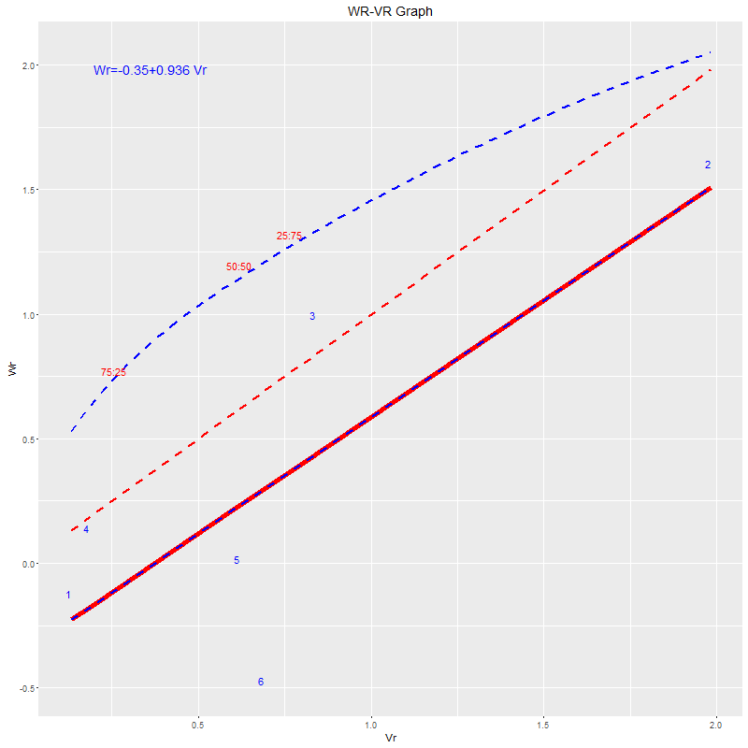
Figure 2: The graph of variance (Vr) and covariance (Wr) for TSS of fruit in the F₁ generation of melon
genotypes.[1:parent IL-CM104, 2: parent IL-CM106, 3: parent IL-CM108, 4: parent IL-CM113,
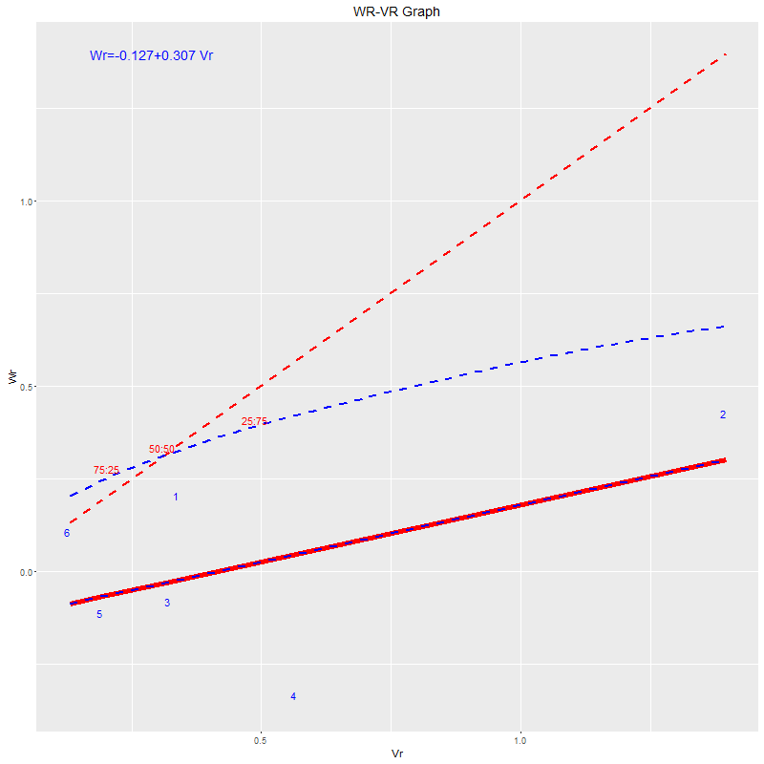
5: parent IL-CM116, 6: parent IL- CM118].
Figure 3: The graph of variance (Vr) and covariance (Wr) for total sugar of fruit in the F1 generation of melon
genotypes.[1:parent IL-CM104, 2: parent IL-CM106, 3: parent IL-CM108, 4: parent IL-CM113,
5: parent IL-CM116, 6: parent IL-CM118].

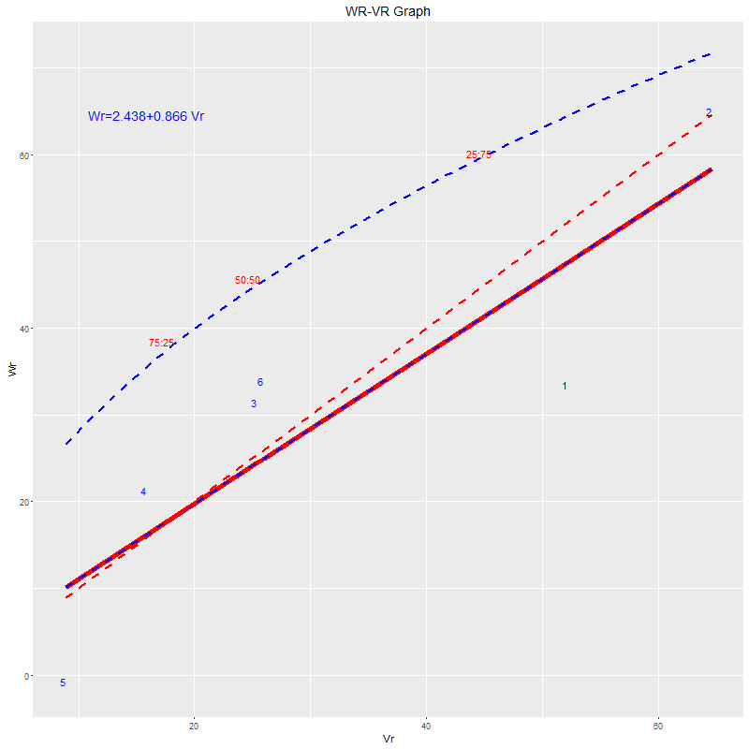
Figure 4: The graph of variance (Vr) and covariance (Wr) for Carotene of fruit in the F₁ generation of melon
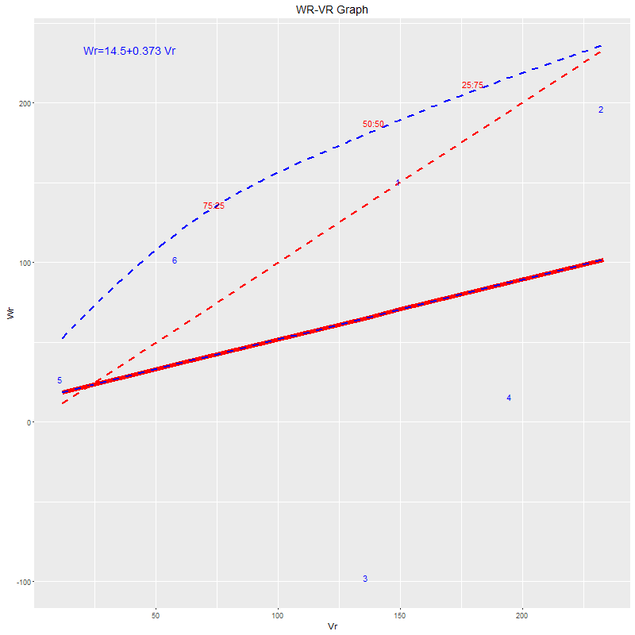
genotypes. [1:parent IL-CM104, 2: parent IL-CM106, 3: parent IL-CM108, 4: parent IL-CM113,
5: parent IL-CM116, 6: parent IL-CM118].
Figure 5: The graph of variance (Vr) and covariance (Wr) for Vitamin C of fruit in the F₁ generation of
Melon genotypes.[1:parent IL-CM104, 2: parent IL-CM106, 3: parent IL-CM108, 4: parent
IL-CM113, 5: parent IL-CM116, 6: parent IL-CM118].
REFFERENCES:
- Abou Kamer, M.E., Yousry,M.M.and El-Gamal, A.M. (2015). Heterosis and heritability studies for fruit characters and yield in melon (Cucumis melo, L.). Middle East J. Appl. Sci., 5(1): 262-273.

- Abo Sedera, F.A., Badr, L. A. A. El- Nagar,M. M. and M. A. M. Ayad. (2016). Inheritance of some Fruit Quality Characteristics of Melon. Middle East Journal of Agriculture Research. 5(4): 789-809.

- Bayoumy, A.M., Yousry,M.M. and El-Gamal, A.M. (2014). Combining ability and sensory evaluation for some hybrids of melon (Cucumis melo L.) Middle East J. Agric. Res., 3(3): 398-411.

- Beerh,O.P. and Siddippa, G.S. (1959). A rapid spectrophotometric method for the detection and estimation of adulterants in Tomato ketchup. Food technology, 13:414-418.

- Burger, Y., Saꞌar, U. Distelfeld,A. and Katzir, N. (2003). Development of sweet melon (Cucumis melo) genotypes combining high sucrose and acid content organic. J. Amer. Soc. Hort. Sci., 128(4): 537- 540.

- Debnath, S.C. (1988). Nature and estimation of genetic components of variation. Acta Agronomica Hungarica, 37: 337-351.

- Glala, A.A., El-Dessouky,S.E.I. and Helmy, Y.I. (2012). Genetic variance analysis for some economic traits of six Egyptian sweet melon lines x three imported tester progeny. Egypt. J. Plant Breed. 16 (3): 169-182.

- Hayman, B.I., (1954). The theory and analysis of diallel crosses. Genetics, 39(6), pp.789-809.

- Iban, E., Jarier, O. Juan, A.M. Jos,M.A. and Esther, V.K. (2007). Estimating the genetic architecture of fruit quality in melon using a genomic library of near isogenic lines. J. Amer. Soc. Hort. Sci., 32(1): 80-89.
- Ismail, M., Sajjad, A. and Hussain, M. (2014). Quantitative Determination of Ascorbic Acid in Commercial Fruit Juices by RedoxTitration. International Journal of Pharmaceutical Quality Assurance.5(4): 22-25.

- Kirk, S. and Sawyer, R. (1989). Pearson composition and analysis of food, 9thed. Longman scientific and technical. New York.p:18-31.

- Mliki, A., Staub, J.E., Zhangyong, S. and Ghorbel, A.(2001). Genetic diversity in melon (Cucumis melo L.): an evaluation of African germplasm. Genetic resources and crop evolution, 48(6), pp.587-597.

- Mohammadi, R., Hamid,D. and Karimzadeh, K. (2014). Genetic analysis of yield components, early maturity and total soluble solids in cantaloupe (Cucumis melo L. subsp. melo var cantalupensisNaudin). YYU J. Agr. Sci., 24(1): 79-86.

- Nunes, G.H.S., Santos Júnior, J.J. Andrade, F.V. Bezerra Neto, F. Menezes,J.B. and Pereira, E.W.L. (2005). Desempenho de híbridos do grupo inodorus em Mossoró. Horticultura Brasileira, 23: 90- 94.

- Pandey, S., Jha, A. Kumar, S. and Rai, M. (2010) Genetics and heterosis of quality and yield of pumpkin. Indian Journal of Horticulture. 67(3):333-338.

- Reddy, B. P. K., Begum, H. Sunil, N.and Reddy, M. T. (2013). Variance Component Analysis of Quantitative Traits in Muskmelon (Cucumis melo L.). Trakia Journal of Sciences. 11(2): 118-124.

- Saha, K., Mishra, S. Choudhary, H. and Mahapatra, S.(2018). Estimates of Genetic Component of Variation in Muskmelon (Cucumis melo L.). Int. J. Curr. Microbiol. App. Sci. 7(7): 1144-1151.

- Sebastian, P., Schaeferb, H. Telfordc,I.R.H. and Rennera, S.S. (2010). Cucumber (Cucumis sativus) and melon (C. melo) have numerous wild relatives in Asia and Australia, and the sister species of melon is from Australia. PNAS 107(32): 14269-14273.

- Shamloul, G.M. and Askar, E.H.(2011). Genetic behavior of yield and quality traits in sweet melon esmalawi variety (Cucumis melon –var agyptiacus) J. Plant Production, Mansoura Univ., 2(12): 1731-1739.

- Singh, A.K., Gautam, N.C. and Singh. R.D. (1998). Studies on combining ability in cucumber (Cucumis sativus L.). Prog. Hort. 30 (3-4):204-210.

- Singh RK, Chaudhary, R.D. (1979). Biometrical methods in quantitative genetic analysis. New Delhi: Kalyani Publ.

- Sousa, J.A.and Maluf, W.R. (2003). Diallel analysis and estimation of genetic parameters of hot pepper (Capsicum chinense Jacq.). Sci Agric 60:105-113.

- Takahashi, M. (1959). Determination of Reducing Sugars by Means of Back Titration against Alkaline Copper Solution. Annual Meeting of the Chemical Society of Japan. 33(2): 178-181.

- Walton, P.D.(1968). The genetics of geotaxis in Drosophila melanogaster. Canadian Journal of Genetics and Cytology. 10(3):673-687.

