Othman D. Amer
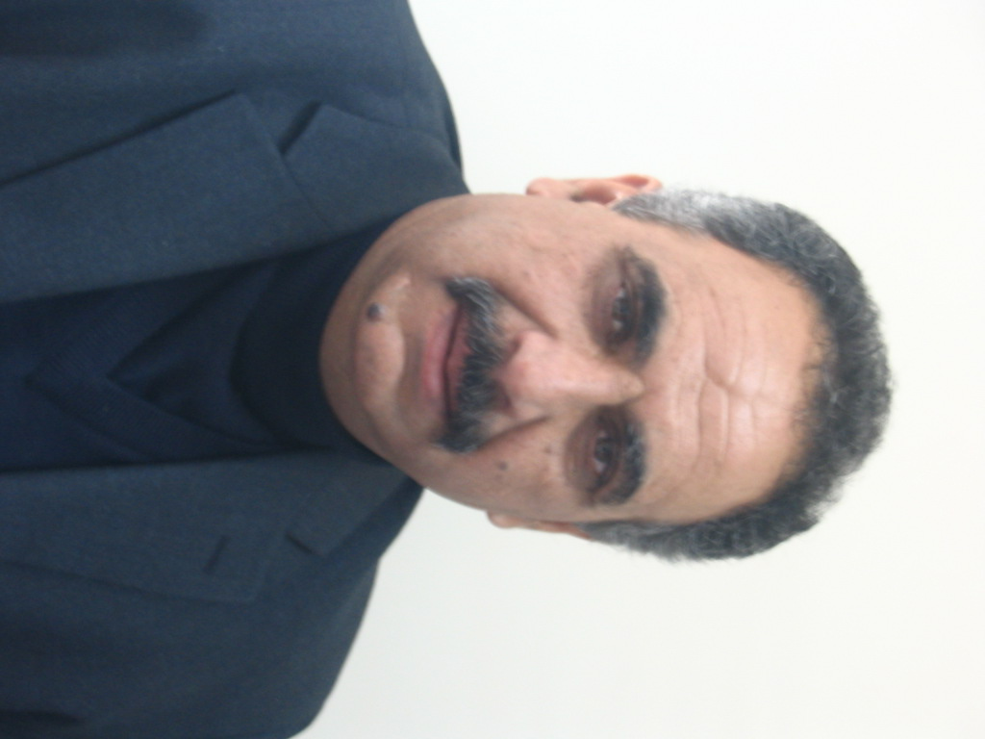

Birzeit University
Department of Lamguages &Translation
Tel: 00972-2-2982000

Home :09-2572115
Mobile : 059751667
E.mail:oamer@birzeit.edu

E.mail:othmanamer53@hotmail.com

Curriculum Vitae

Name : Othman Diab Mussa Amer
Date of Birth : May 25, 1953.

Place of Birth : Jenin
Status : Married

Education:

2002 : M. A. in Education/ English language program/ Beirzeit University.
9/1975 : B. A. in English Language and Literature, University of Jordan, Amman, Jordan
6/1971 : Tawjihi (General Secondary School Certificate /Scientific Stream) Salahiya secondary school – Nablus.

Professional Experience

Present: Full time instructor at Birzeit University
2006-2012 : Director of Languages Department/PCDC
1998–2006 : Head of English /PCDC.
2000-2006 : Member and Rapporteur of Authorship Supervisory Committee/ English for Palestine Grades 1---12 in partnership with Macmillan English Language Teaching.
2000-2011 : Traveling annually to U.K. in follow up with preparing, writing, and editing English For Palestine Series, Grades 1-12 with authors at Macmillan.
7/1998 : Member and Rapporteur of the English Language National Team for setting English Language Curriculum General Guidelines for Public schools in Palestine Grades 1-12.
10/1987 : Supervisor of English Language for the Intermediate and Secondary Stages / Ministry of Education / Saudi Arabia.
9/1978 : Teacher of English Language / Intermediate and Secondary Stages / Ministry of Education / Saudi Arabia.
10/1975 : Teacher of English Language, Preparatory and secondary stages, Teachers’ Training Institute / Ministry of Education Libya.
90-2012 : Legal interpreter and translator in many workshops. One about was Policy Development of Textbook Printing Sector arranged by the UNESCO and the PCDC/ February 2000.The latest was about Money Laundering/World Bank,Ramallah/2007.
Interpreting and translating from Arabic to English and from English to Arabic. I have translated:
2007 : Education for All
- : First Palestinian Curriculum Plan from Arabic to English. A copy is available upon request.
2003 : Children Under the Fire of Terrorism.
2002 : The History of Central Palestine in the Middle Ages.
2004 : A film about Facts and Expectations for the Ministry of Education & Higher Education.
2004 : Brochures about Inclusive Education & Education for All. Documents, Plans, and Programs for the Ministry of Planning.

Participations :

2009 :Participating in the 43rd IATEFL Conference/Cardiff,31March-4April .
2008 :Participation in Arab European Days for mutual cooperation and Better Understanding Symposium ,arranged by ALECSO/ October 2008/Tunisia
2008 : Presenting a paper about Teachers’ Problems in Teaching English/ Quality English Teaching: Encountering Challenges/First National Symposium/ Birzeit University/ Aug.30-31,2008 .
2007 -2008 : Member of Teacher Education Reference Group(TERG) which produced Teacher Education Strategy in Palestine 2008 .
1998-2008 :Member of PATEFEL : Palestinian Association of Teachers of English as a Foreign Language
97-2008 : Participation in several workshops in: Assessment and Evaluation, Gender and the Curriculum, Integrative Education, Statistics and Policy Making, Life Skills Education in the Curriculum.
- 1999 : Participation in the Summer Institute Program: “The Study of U.S. for Foreign Secondary School Educators” held from June 19 to July 30,1999 at the University of Illinois /Chicago.
87- 97 : Training teachers of English through intensive courses in Methodology/Saudi Arabia.
2000-2008 : Member of the English language Team for training Teachers’ Trainers of English for Grades 1-12.
April-2000 : Member of the National Team for preparing and implementing the First Achievement and Performance Test in English for Grade 5.
2003 : Attending the British Council international seminar The Perfect School Curriculum: Myths and Realities, Cardiff 26-31 January 2003.

2002—2012:Part –time instructor of English/Birzeit University

Languages:

 | Reading | Writing | Speaking
Arabic | Excellent | Excellent | Excellent
English | Excellent | Excellent | Excellent
German | Fair | Fair | Fair

Present Job Description : Leading the national team of authors of English For Palestine / and heading meetings via video and phone conferences with authors at Macmillan(Development and Enrichment of school textbooks Grades 1-12)

Developing English Language training Programs for teachers of English .

Involved in reviewing, developing and improving English for Palestine Curriculum .

Setting and preparing English tests in cooperation with experts from Macmillan for Grades :4 , 6 ,8 , and 10 in Public schools in Palestine.(May ,2009 ).

SUZAN SHEHADA
- Ramallah, Palestine Cell: 0598254222 sshehada@birzeit.edu

_________________________________SUMMARY__________________________________

To acquire a position that will enable me to develop my skills and to work my way up into a position with higher responsibilities.
_________________________________SKILLS______________________________________

- The ability to manage and make use of time, in addition to the capability of working under pressure.
- Use correct grammar and clear speaking voice. Good presentation skills.
- Flexibility in different situations. Good communication skills.
- Capability in decision making.
- Self-motivated. High energy, patience and creativity.
- Capability in using Microsoft office, word, power point.
- Highly organized.
____________________________WORK HISTORY_________________________________
Instructor, 02/2015- present
Birzeit University- Palestine
EFL Instructor
Course coordinator,
- Administrator for the Unlock online material at Birzeit University
____________________________EDUCATION______________________________________
Summer 2006- summer 2007, Al-Esra’ girls school Literary stream
Birzeit University
BA: English literature, Spring 2011
Birzeit University
MA: Education (Teaching English as a Foreign Language), Summer 2014

__________________________REFERENCES_______________________________________
Dr. Saeb Al-Qawas
Instructor at Birzeit University
University of Bath, England.
0546876238
Dr. Majdi Abu-Zahra
Translation Department (Birzeit University)
022982099
Adnan Abu Ayyash (Birzeit University)
022982099
____________________________LANGUAGES____________________________________
English and Arabic.

