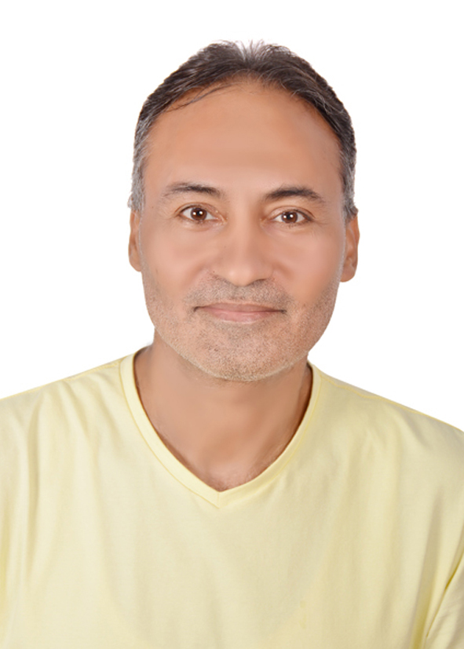
Atef H.Elasouly , PhD
Associate Professor,

Faculty of Social and
Family Development.
Al-Quds Open university,
Gaza - Palestine.
Mobile : 00970599774305
http://aasouliresearch.blogspot.com
http://aasouliarticle.blogspot.com

EDUCATION
- PHD in social work (2010) Sudan university of science and technology – Sudan ( social work )
- Master of Sociology, IARS, February 2000, Cairo-Egypt,
- Post-graduate Diploma in Sociology , IARS, 1996, Cairo-Egypt,
- Bachelor of Social Work, The High Institution for Social Work, 1991, Cairo-Egypt.

EXPERIENCE
-Member of the Child Protection and MHPSS working group, UNICEF - Gaza,
-Member of the Age-friendly Environments Mentorship Program (AFE) of the World Health Organization (WHO-IFA) and the International Federation on Ageing.
-Member of the American Sociological Association (ASA)
-Member of editorial board in ijaiem journals"www.ijaiem.org/editorial.php"
- Training of trainers in Psychosocial Support, social work skills, family intervention, leadership skills, social case work, case management, group work etc.. in prcs, Islamic relive Gaza ,National agency for family care, Friends of the kind heart society, ministry of social affairs ,ministry of interior ,Islamic university , People's Committee for the refugee camp, war child association , world vision , etc..
- Associate Prof. in social work, Al-Quds Open University, Gaza Branch, Palestine, sept.2000 – present.
- Lecturer (social work department, faculty of arts) At Islamic Uni. Palestine, sept.2000 – 2009.
- Lecturer (social work department, faculty of arts, AlAzhar Uni. Palestine, sept.2003 – 2007.
- Technical supervisor in mental health project for Ems. In Gaza strip PRCS -ICRC.( 2001-2004 )
- Technical supervisor in psychosocial centers PRCS - ITRC ( 2004- 2010 )
- Psychosocial Consultant in PRCS- Qatar Red Crescent (2011 -2014).
- Psychosocial Consultant "volunteer" in PRCS 2014 present.
psychosocial Consultant cooperation with some social worker and psychologist working in " Gaza Community Mental Health Program - Basma society for Culture and Arts - CTCCM (Community Training Center and Crisis Management) - Palestine trauma center - Charity Give Association - Reyada Association for Social Development - Tagreed Association for Culture and Development - Alrwad Association for Palestinian youth , , etc..
- Training supervisor (social work students), Gaza, Palestine, sept.2000 – present.
- -Social Worker in mental health , Palestine hospital-Palestine Red Crescent Society (PRCS), Sept. 1996-2000, Cairo , Egypt
- Social Worker in mental health, Omar Shaheen hospital for mental health, 1992-1996, Giza Government, Egypt.
- Trainee, Several Institutions work At social fields, 1988-1992, Egypt
Researches published in scientific journals
"1-research published in the Journal of Science and Technology issued by the University of Sudan for Science and Technology: the first issue July 2012 on the ethics of practicing the profession of social work in Palestine.
2-Research published in the Journal of Palestinian research and humanitarian studies, "Persa" on the characteristics of scientific researcher in the Palestinian universities No. 18 2012.
"3-research published in the Journal of Palestinian Research and Humanitarian Studies "Persa" on the reality of social care for orphans in Palestine "Field study on a sample of children of housing institutions in the Gaza Strip" October 24, 2015.
4-Research published in the Journal of the Palestinian University for Research and Studies on the social responsibility of the media towards people with disabilities No. 2 June 2016.
5-Research published in the scientific magazine of the Technical College of Palestine on the living conditions of Palestinian families in the shelters in UNRWA after the Israeli aggression on Gaza in 2014 September 2017.
6-Research published in Jerash Journal for Research and Studies "The reality of the problems of retirement age from the point view of a sample of the employees of the Association of retired employees in Gaza City / March 2018. 7. Research published in Research published in the global Journal, Obstacles that limit opportunities for gender equality In Palestinian Universities, vol.3, 2020.
Researches published in scientific conferences 1- research published in Zagazig University conference on "Models of good practices to contain domestic violence in the Gaza Strip 28-29 November 2012.
2- Research published in the conference of colleges and departments of Arab social work of the General Federation of Universities, the Arab Social Work and Colleges Magazine No. 2, 2015 on the role of social institutions in early intervention for the protection of battered women, a field study on a sample of women from the safety house for social care in Gaza. 3- Research published in the first international conference on learning difficulties in Algeria 19-21 April 2016 "the experience of the integration of students with physically disabled people with learning disabilities in the Association of the physically disabled in Gaza.
4 -Research published at the International Conference on Community Responsibility for Arab Universities, Zarqa University, Jordan, in cooperation with Al-Quds Open University / Social Responsibility, Al-Quds Open University, Towards Released Detainees', April 2017.
5-Paper offered in the International Conference of Social Sciences, Al-Quds University / The reality and responsibility of university youth towards community participation "oral presentation" March 2018..
-Attended and participate in a series of conferences, workshops, in (Egypt – Sudan – Palestine) on " mental health - psychiatry – psychosocial Support "MHPSS" – Social work filed, etc…
Authors
1-Published book, The role of social work in the detection of the characteristics of perpetrators of rape crimes - Gaza Central Prison, I 1, Noor Publishing Foundation, New York, 2017.
2-Published book, Domestic Violence crimes, I 1, Noor Publishing Foundation, New York, , 2018.
3-book submitted for publication "Autistic Child between Diagnosis and Treatment - The role of the family in full recovery", in El Noor Publishing Foundation ,2018

SKILLS
Computer Skills | : | Excitant
Language Skills | : | - Fluent in spoken and written Arabic (mother-tongue)  - Good command of English  - Knowledge of Hebrew

PERSONAL DATA
Date of Birth | : | April 12, 1970
Place of Birth | : | Cairo-Egypt
Nationality | : | Palestinian – Egyptian
E-mail | : | aasouli@qou.edu

